Servicios

- computo

- web

- almacenamiento

- BBDD

- red

- IA

- DevOps

- ENtornos

- Serverless

- IoT

- Seguridad

NIvel de servicio

- acuerdos

- ciclo de vida de servicio

- admon de costos de servicio

Certificaciones

https://docs.microsoft.com/en-us/learn/certifications/

Certificacion Azure fundamentals

https://docs.microsoft.com/en-us/learn/certifications/exams/az-900?tab=tab-learning-paths

Practicas de examen

<https://www.measureup.com/catalogsearch/result/?q=AZ-900>

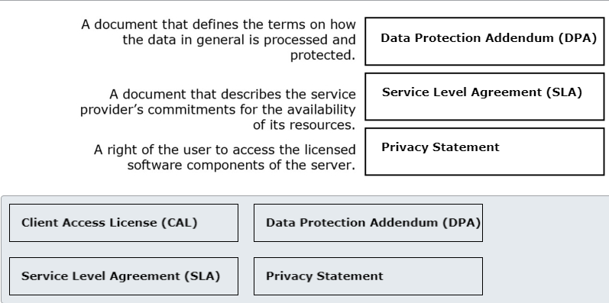

BENEFITS to cloud migration

Pay-per-use model

Fixed recurrent costs

NOT OWNERSHIP OF PHYSICAL INFRASTRUCTURE

NOT ABSENCE OF UPFRONT COSTS

NOT REDUCED SERVICE LEVEL AGREEMENT

User1 should be able to assign access and

assign policies to "management group"

WHICH ROLE-BASED ACCESS CONTROL (RBAC)

ROLE USER1 SHOULD BE ADDED.

- contributor

- user access admin

- owner

- management group contributor <-?

Which configuration to host 200 miles geographical area

- availability zones

- region pairs <-

- availability sets

is a service that brings together enterprise data

wherehousing and BIg Data analytics

azure event hub

azure sphere

azure stream analytics

azyre synapse analytics

Cloud concepts 0

Azure services 1

solutions and mgmt tools 1

identity, governance, privacy compliance 0

NIVELES

Fundamentals

Associate

Expert

Specialty